Design for Medical Innovation (August-2017 )
Challenge:
The Design for Medical Innovation Challenge gives you a chance to amplify your skills in support of your future career and an opportunity to share your designs to transform lives through innovative medical solutions that improve the health of patients around the world.
Use Autodesk® Fusion 360™ to design submission/s to one or both categories:
Category One: Design a New Piece of Medical Equipment
Innovate and design a new piece of medical equipment you would find in a connected doctor’s office. You may be very creative and invent a new type of equipment, or you may want to simplify the doctor’s office and combine multiple pieces of equipment into one cohesive, ergonomic piece. Be creative, now is chance to design a piece of the future. Examples of medical equipment you’d find in a doctor office are: scale, thermometer, and computer on a stand, a device to measure blood pressure, blood oxygen percentage and pulse.
Category Two: Aesthetically redesign the Latitude Consult System
- Esthetically Latitude Consult System, which is used to read data from a patient’s implanted device via a telemetry wand placed over the patient’s device. Once the data is read, the clinician uses the Communicator to send the data to the secure Latitude Consult server. The next generation Latitude Consult System can be operated by the patient at their bedside or be conveniently moved around the home.
- Your challenge is to update the design so that blends into a contemporary bedroom or household. You may want to consider giving the Latitude Consult System added functionality, like a clock-radio, or a phone, so it not only blends into it’s surroundings it also replaces something you’d find in a normal home.
Simply create 3D models of your design concept/s and take into consideration aesthetics, comfort, portability, mobility and connectivity in a modern world. You can submit one designs in each category. Top five will awarded with cash prize of 3000Rs each. Certificate and goodies will be provided to each participant.

Winners:

SIDDHARTH SINGH  2016UME1165  B.tech mechanical engineering  Project title: Latitude consultant system | 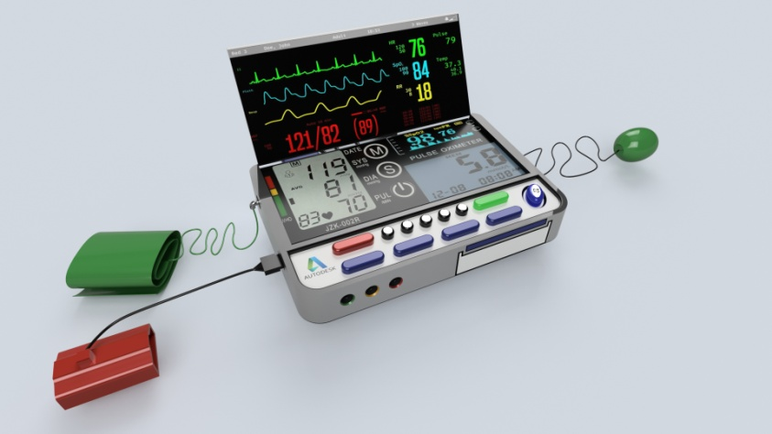
AMIT KABDAL  2015UME1526  B.tech mechanical engineering  Project title: Innovative bed for Patient | 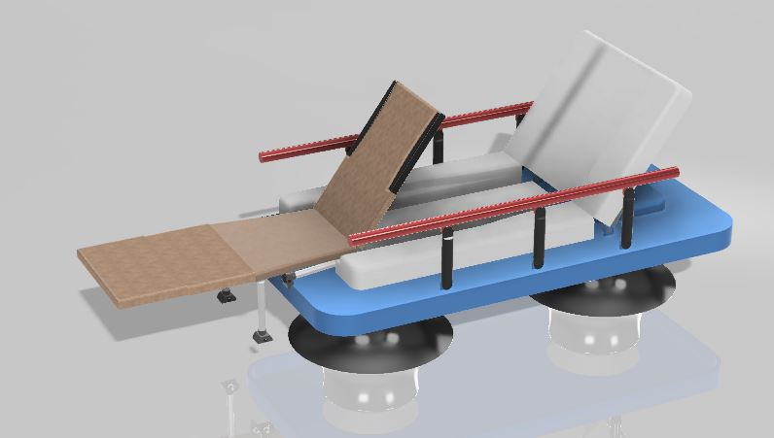
KUSH KUMAR  2016UME1261  B.tech mechanical engineering  Project title: Open MRI machine | 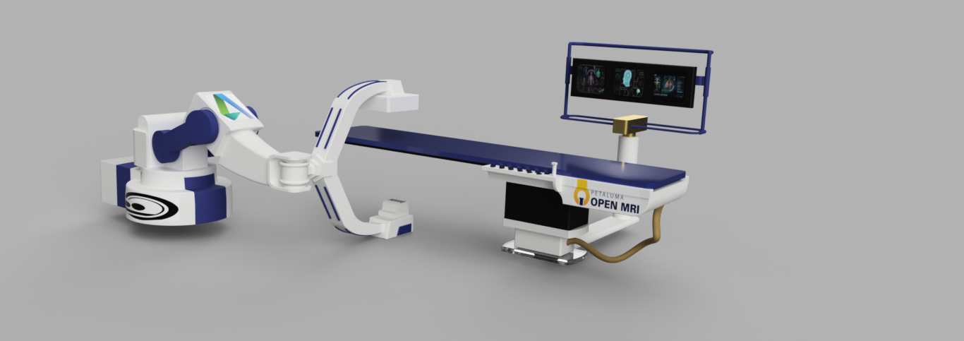
ABDUL RAHMAN MOIN AZMI  2015UME1464  B.tech mechanical engineering  Project title: Innovation In Medical Instrument | 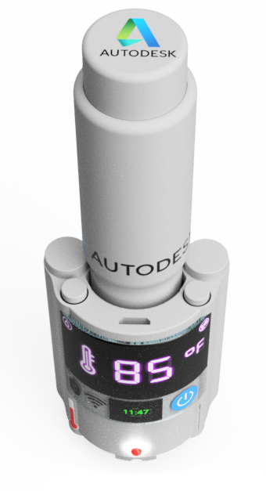
AJAY JANGRA
2015ume1391
B.tech mechanical engineering
Project title: Latitude consultant system

